OUM

DO.070 User Guide

Al-Gihaz Holding –ERP

Oracle Projects -

Actual Dates & Project Versioning

|  |  |
| --- | --- |
| **Author:** | Muhammad Daniyal Khurshidi |
| **Creation Date:** | 30–May-2016 |
| **Last Updated:** | 31–May-2016 |
| **Document Ref:** | AG_UG_PM_AD&PV |
| **Version:** | v1.0 |

1. **Title, Service Name, Last Updated Date, Reference Number**, **andVersion** are marked by a Word Bookmark so that they can be easily reproduced in the header and footer of documents. When you change any of these values, be careful not to accidentally delete the bookmark. **You can make bookmarks visible by selecting Tools->Options…View and checking the Bookmarks option in the Show region.**

**Approvals:**

|  |  |  |
| --- | --- | --- |
| **Approver** | **Designation / Role** | **Signature & Date** |
| Hassan Mujahid | Raqmiyat Project Manager |  |
| Dr. Tarek Amer | AG Commercial Director |  |
| Ahmed Al Sokkary | AG Project Manager |  |
|  |  |  |

# Document Control

## Change Record

3

| Date | Author | Version | Change Reference |
| --- | --- | --- | --- |
| 31–May-2016 | Muhammad Daniyal | V1.0 | No Previous document |
|  |  |  |  |
|  |  |  |  |
|  |  |  |  |
|  |  |  |  |
|  |  |  |  |

## Reviewers

| Date | Name | Position | Signature |
| --- | --- | --- | --- |
|  | Muhammad Daniyal | Project Consultant – Raqmiyat |  |
|  | Hassan Mujahid | Raqmiyat Project Manager |  |
|  | Dr. Tarek Amer | AG Commercial Director |  |
|  | Ahmed Al Sokkary | AG Project Manager |  |
|  |  |  |  |
|  |  |  |  |
|  |  |  |  |

## Objective

This document will demonstrate & illustrate how to update actual dates for a task and how to do project versioning.

## Audience

This manual is prepared for Al-Gihaz Projects Business Cycles. The concerned department is Projects.

## How to use this manual

Through the Contents, the user can see how we can update actual dates in a task and how to create version for project baseline..

As per the Future Process Model document; the users will be focused only on certain topics and transactions as per their role.

**Contents**

1 Document Control 2

1.1 Change Record 2

1.2 Reviewers 2

1.3 Objective 3

1.4 Audience 3

1.5 How to use this manual 3

1.6 How to Update Actual Date for a Task 5

1.7 How to Create Version for Project Baseline 6

## How to Update Actual Date for a Task

1. Log in to Oracle.
2. Go to Project Billing User – AGC responsibility.
3. Search for your project.
4. After search result appear, open the project.
5. Click on Structure in the Options section & Press the Detail button.
6. Go to the Workplan tab select hierarchy and Press Go button.

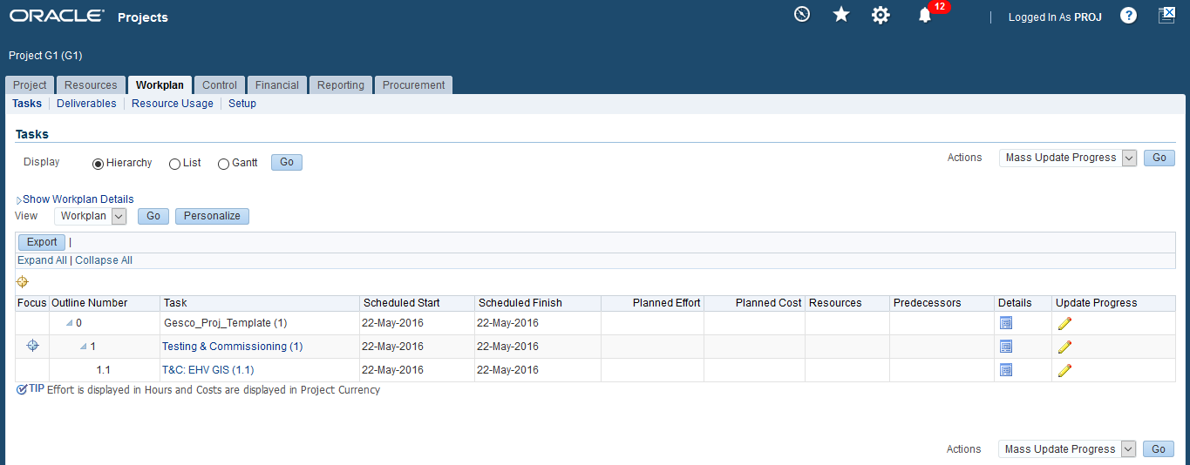

1. Click on the Update Progress pencil icon for the lowest level task for which you want to update Actual dates.
2. Scroll down on the Update Task List Details page and enter the Actual Dates.

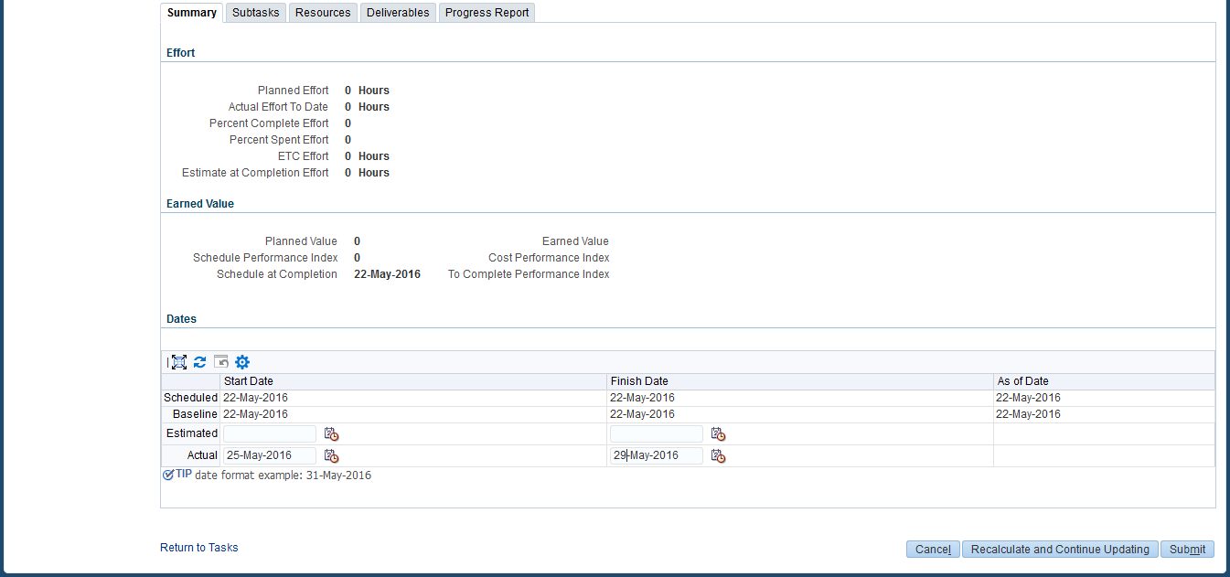

1. Now click on the Progress Report tab.
2. Select the correct Task Status.

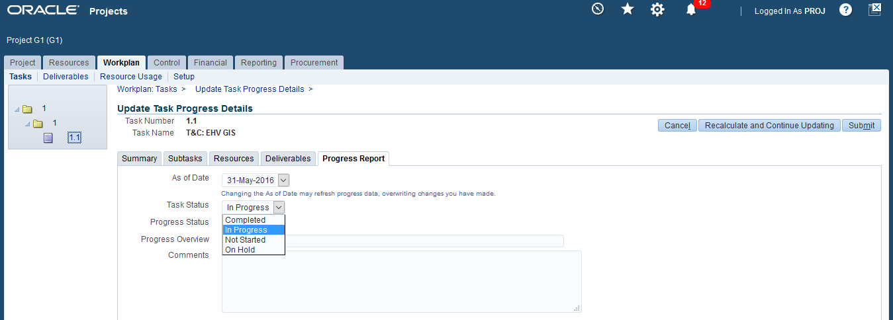

1. Click on the Submit button.
2. System will ask for confirmation, Press the Yes button.
3. The Actual Dates along with the Task Progress Status has been updated.
4. If you want, you can go back to the Summary page to verify that the changes have been saved.

## How to Create Version for Project Baseline

1. Log in to Oracle.
2. Go to Project Billing User – AGC responsibility.
3. Search for your project.
4. After search result appear, open the project.
5. Click on Structure in the Options section & Press the Detail button.
6. Go to the Workplan tab select Maintain Version from the Actions menu and Press Go button.

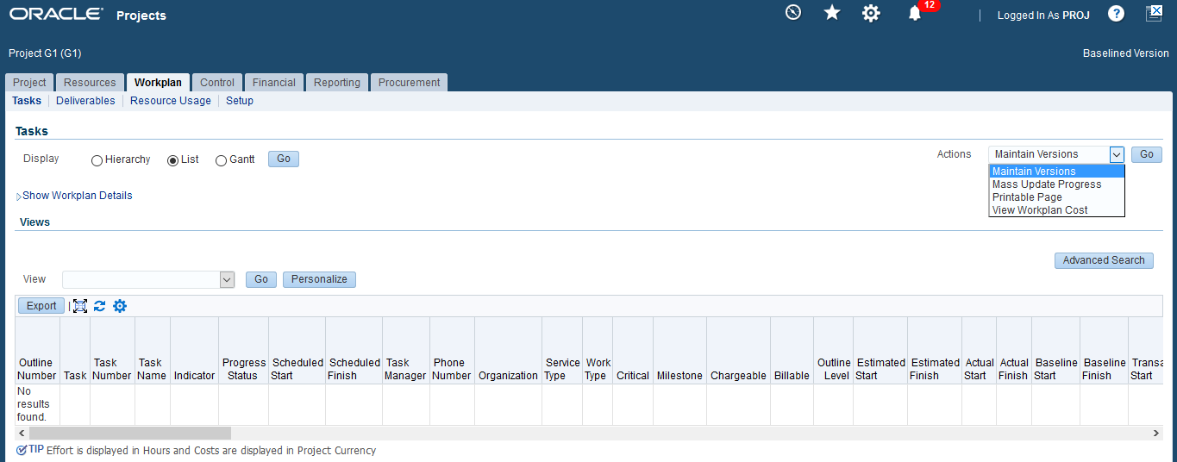

1. Select the existing Workplan and Press Create Working Version button.

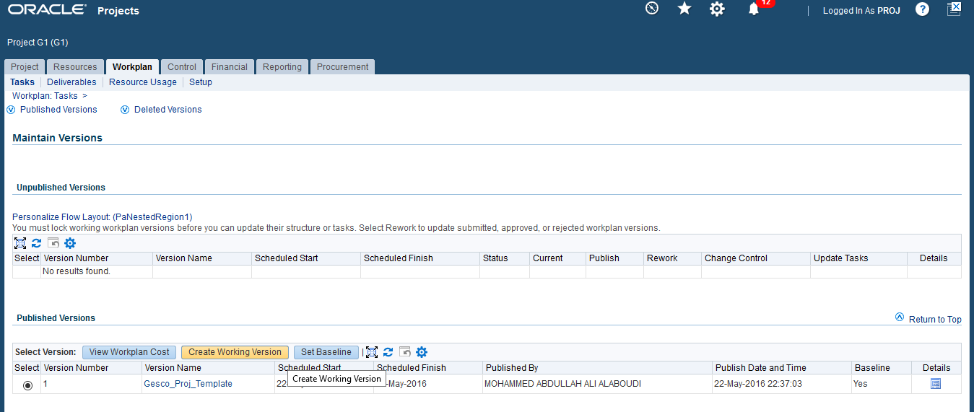

1. Enter new version name and select change reason and Press Apply button.

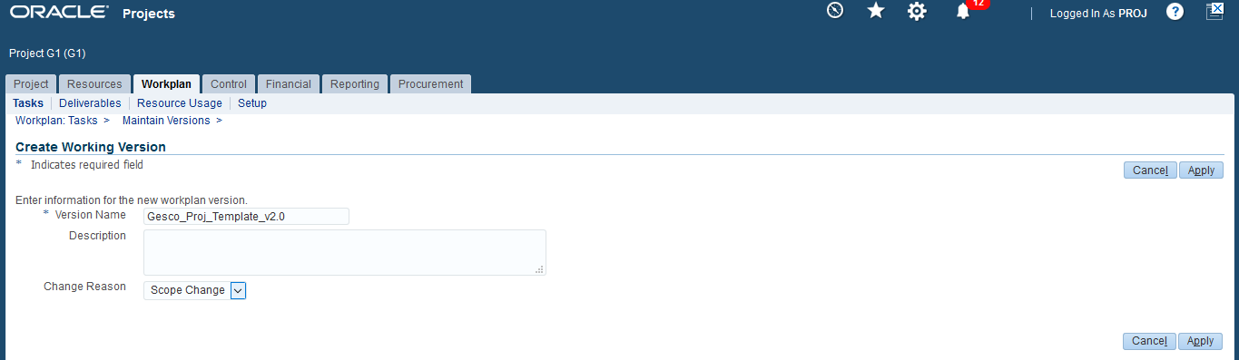

1. After the new version is created, select it and press Update Task icon for editing the Working Version of the Workplan (which we created just now).

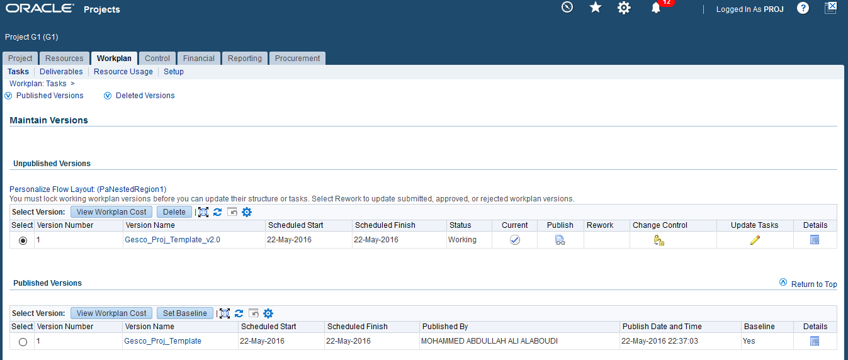

1. Once the changes are finished, Select Continue Updating and then click on Go button. Once the changes are saved, click on Review & Publish Workplan button.

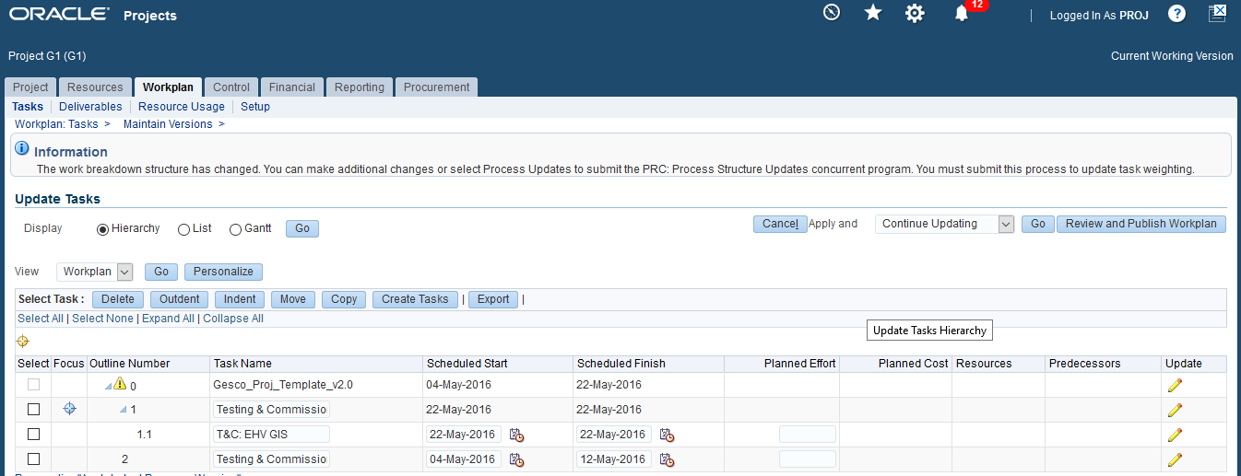

1. Once the new form opens click on Publish button. This will publish the working version after which we can make it as baseline.
2. Now select the new version of the workplan and click on Set Baseline button.

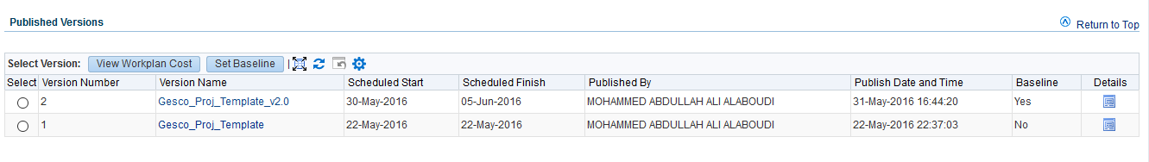

1. As it can be seen above the workplan version 2 has been set as the baseline and version 1 is maintained as history.
2. If it is required to make the old version as baseline, from the same form just select the old version and again press Set Baseline button.
3. The system will always display/reflect the current Baseline version of the Workplan and the old versions will be maintained as History.